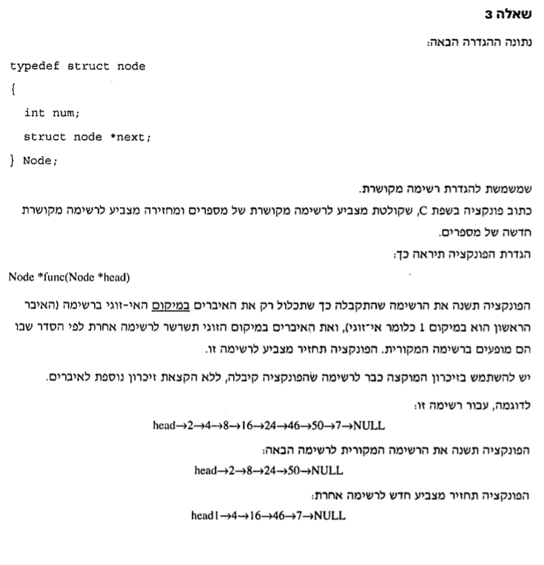

Node \*func(Node \*head)

{

Node \*head1 = head->next;

Node \*current = head;

Node \*current1 = head1;

while (current->next->next != NULL && current1->next->next != NULL)

{

current->next = current->next->next;

current1->next = current1->next->next;

current = current->next;

current1 = current1->next;

}

current->next = NULL;

current1->next = NULL;

return head;

}